

Task1

By looking at the information in the HTTP GET and response messages,

answer the following questions

Is your browser running HTTP version 1.0, 1.1, or 2?

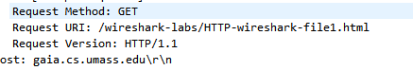

What version of HTTP is the server running?

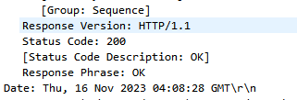

What languages (if any) does your browser indicate that it can accept to the server?

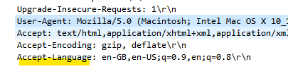

What is the IP address of your computer? What is the IP address of the

gaia.cs.umass.edu server?



What is the status code returned from the server to your browser?

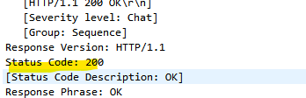

When was the HTML file that you are retrieving last modified at the server?

How many bytes of content are being returned to your browser?



Task 2:

**Inspect the contents of the first HTTP GET request from your browser to the server. Do you**

**see an “IF-MODIFIED-SINCE” line in the HTTP GET?**

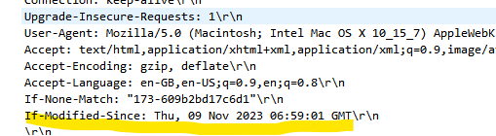

Inspect the contents of the server response. Did the server explicitly return the contents of the

file? How can you tell?

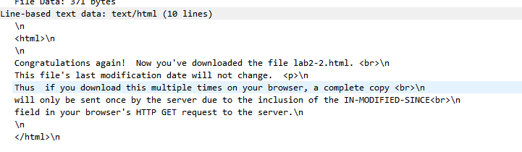

3. Now inspect the contents of the second HTTP GET request from your browser to the server.

Do you see an “IF-MODIFIED-SINCE:” line in the HTTP GET ? If so, what information

follows the “IF-MODIFIED-SINCE:” header?



We can see the data and time:

What is the HTTP status code and phrase returned from the server in response to this second

